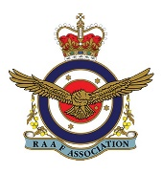
Merriwa AFA Bowling Club present a

Dinner Dance
at Merriwa RAAFA Estate
Saturday May 11 2019 at 6pm
Dancing to the AUSTRALIAN ARMY BAND, PERTH until 10.30pm
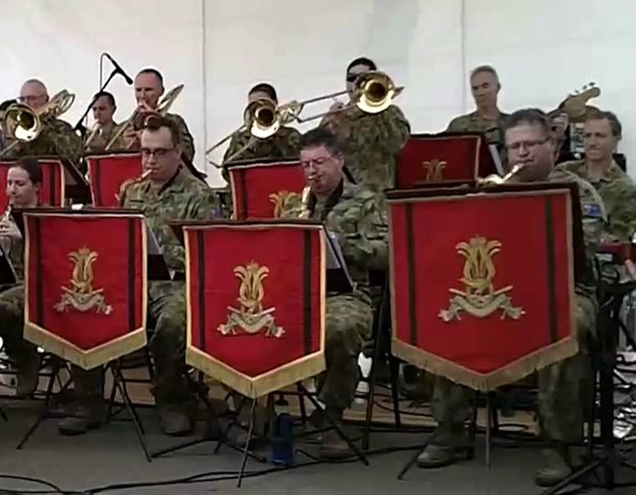

Tickets (to include main meal and dessert) $40
Jacket and tie for men
Tickets and table bookings available from Maggie Edgar – Unit 88 (9400 3488)
This event replaces the usual Friday night bistro.
ALL PROCEEDS TO BE DONATED TO LEGACY

